Added notes from meeting 4/7/16 in blue
Status indicated by highlight color (green = done)

Hi Everyone,

I received the new XML for our model chapter, Chapter 3, and much of the requested changes are in there, with a few exceptions. I’d like to go over a few of the basics one more time, so please indulge my questioning (questionable?) mind. I want to make sure we are all in agreement before making these changes, because some are a bit different than in other titles.

Key Terms
Key terms within the text of the book will NOT popup the definition. The definition will appear in the right margin, styled as in the PDF.

Problems Section
The problems section will be a simple list. There will be NO interactivity, not even Show Answer buttons and boxes. I’m asking this again because the XML is delivered with a “solutions” XML file that corresponds with the questions asked in the Problems section. I will be ignoring this solutions file and providing no answers.

Check Your Understanding
The end of each chapter has a Check Your Understanding feature, which will have a Show Answer button. A flash card file was mentioned in the meeting we had, but I don’t believe I have that file. Please tell me where I can find that file (XML server?). Also, there is a phrase at the bottom of these features: “Solutions appear at back of book.” I assume I should remove that line.

Key Terms Quiz
In need definitions for the key terms matching quiz. A flash card file was mentioned in the meeting we had, but I don’t believe I have that file. Please tell me where I can find that file (XML server?). The Key Term quiz section has answers that will be provided later.

Lists
I will implement all numbered and lettered lists with bold numbers and letters rather than the default, non-bold lists of HTML.

Tables
All unnumbered tables have been implemented as HTML, as specified. The unnumbered tables have no associated supplemental windows and will not popup a window when clicked.

There remain 3 numbered tables. They can be implemented in HTML, and they can be programmed to popup supplemental windows. However, the tables in those supplemental windows will be the same size as those in the main page.

If numbered tables are implemented like numbered figures, using image files, then larger versions of these tables can be displayed in the supplemental windows. Also, development time would be less and there would be no difference in appearance compared with the PDF. These particular tables have complications that will lead to some differences if created in HTML versus image files.

Numbered Figures
As suggested, I opened the wrapper course for krugmanwellsmicro4 to see how numbered figures were implemented. It’s an interesting approach, but there are a couple drawbacks:

- The supplemental window contains the figure in the same size as the main window. It is not enlarged.
- The figure uses an image that includes not only the white-background chart, but also the blue-background text that surrounds the charts. Such images would need to be supplied, or we could cut them from the PDF ourselves, if you prefer. They should be supplied as one image per figure. In the example below, 3 charts and their text are supplied in one image file which contains the 3 charts and text (shown below).

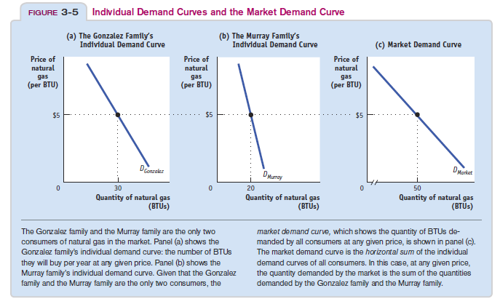

Supplied image file should appear like this:

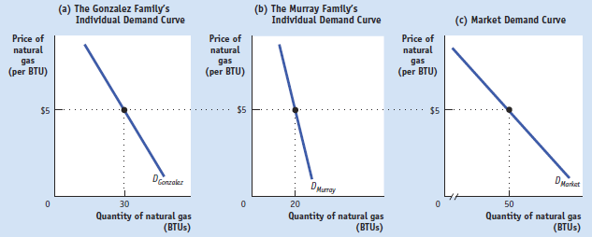

Credited Images
A new set of images will be delivered that contain embedded credits.

Other Side-by-side Images
The simplest solution for side-by-side images is to combine them into one, as with the numbered figure images mentioned above. This solves a number of issues, such as when a caption is to be shared between images, and with display in supplemental windows. Combining images like this would avoid complications as the e-book is built out and simplify the process for everyone.

Thanks again for your indulgence, Everyone!

Meade

New items from meeting 4/7/16 (yellow highlight = new functionality added)

Problems section
There are no answers or quiz activities. It is correct as implemented in the model chapter (3). However, supplemental windows containing the content of each question will be added. These windows will pop up when the question number is clicked.

Check Your Understanding
The Check Your Understanding feature found at the end of section pages will have Show Answer boxes. The answers themselves will be provided later. The questions contained in these sections will have popup windows like those in the Problems section.

Key Terms Quiz
The Key Term quiz section has answers that will be provided later.

Solved Problem
The Solved Problem feature will be converted into a new A-head section of its own.

